# Assignment

The aim of the assignment is a build a responsive html page using Bootstrap 4 & jQuery. On this page, the user will provide her profile information.

# Table of Contents

Submitting Your Assignment

Frameworks & Plugins

UI Specifications

UI Specs for breakpoint upto SM (576px) (Mobile View)

UI Specs for breakpoint SM (576px) to LG (1200px)

Specs for breakpoint XL ( > 1200px)

Color & Font Specification

UX Requirements

Validations.

On Save Button Click

Cancel Button Click

## Submitting Your Assignment

You need to host your solution on [github](https://github.com/) and provide us with link to your repository. You need to create a folder with following structure:

* app
  + javascripts
    - All your JS files go here
  + css
    - All your CSS files go here
  + Index.html
    - This is the html page, the end result.

## 

## Frameworks & Plugins

You need to use following frameworks to complete this assignment:

1. Jquery - <https://jquery.com/>
   1. You can download the required version and use it
   2. Alternatively, you can also use CDN. CDN URL can be found here - <https://code.jquery.com/>
2. jQuery Validation Plugin - <https://jqueryvalidation.org/>
3. Bootstrap 4 - <https://getbootstrap.com/>
   1. Documentation: <https://getbootstrap.com/docs/4.1/getting-started/introduction/>
4. You are free to choose an open-source plugins for custom drop-down & date-picker. Examples: <https://silviomoreto.github.io/bootstrap-select/>

<https://tempusdominus.github.io/bootstrap-4/>

1. You are free to use any other plugin, but, the use of above frameworks/plugins is mandatory. Asd

## About UI Specifications

UI Specifications have been provided below. These specifications explain how the page should look in different screen sizes (also known as responsive breakpoints). Please refer <https://getbootstrap.com/docs/4.1/layout/overview/#responsive-breakpoints> . Colour & Font Specifications have been provided separately.

## UI Specs for breakpoint upto SM (576px) (Mobile View)

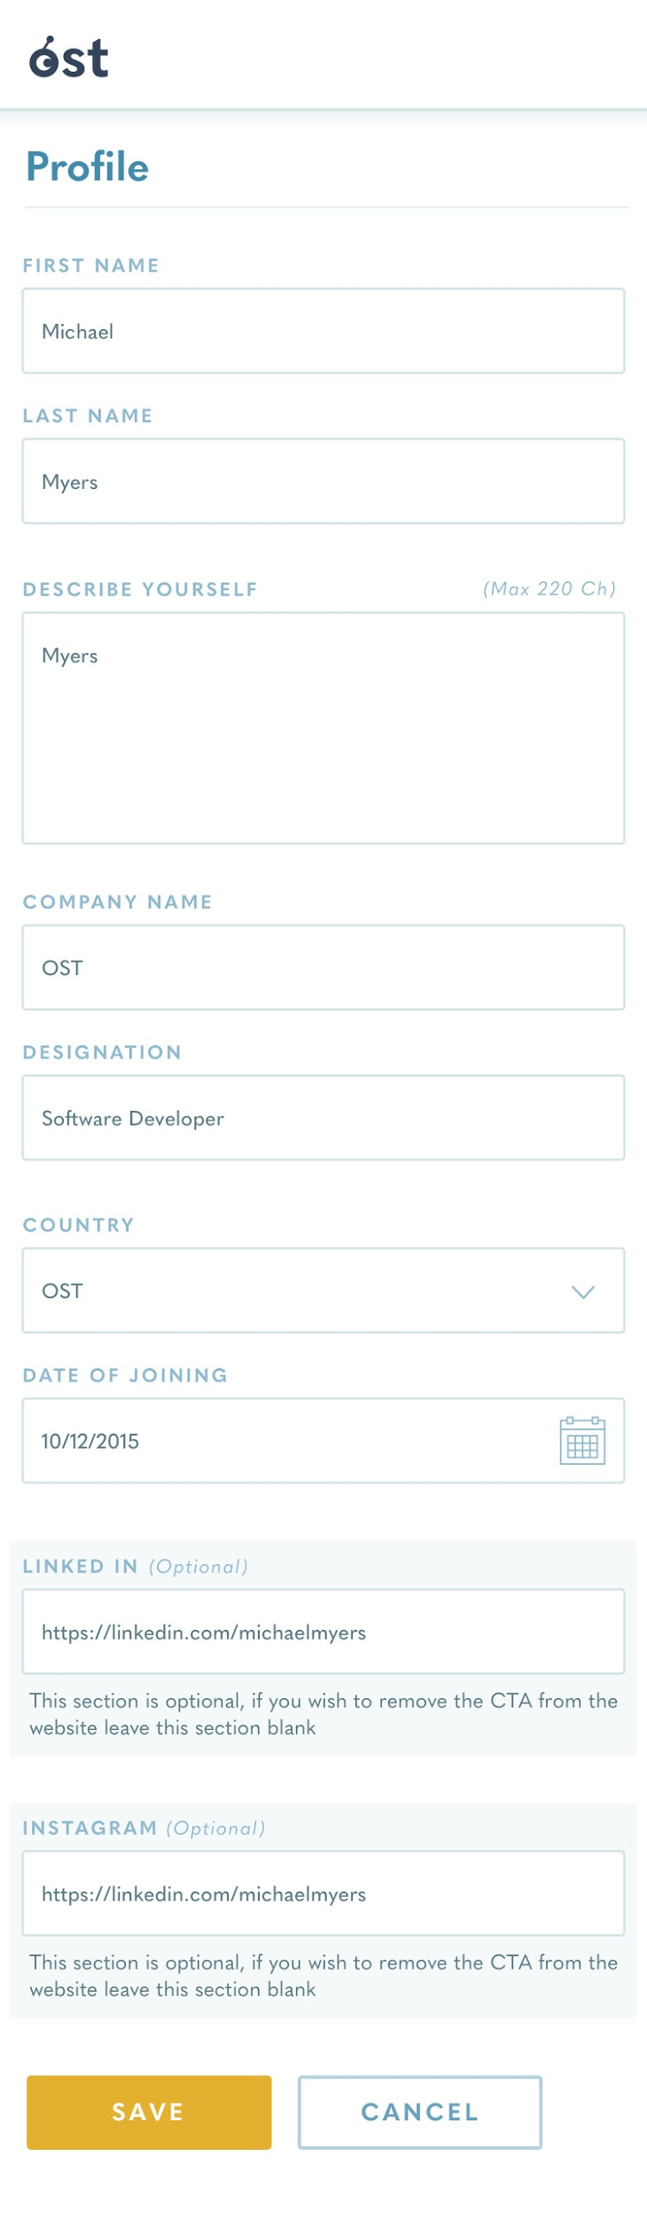

## UI Specs for breakpoint SM (576px) to LG (1200px)

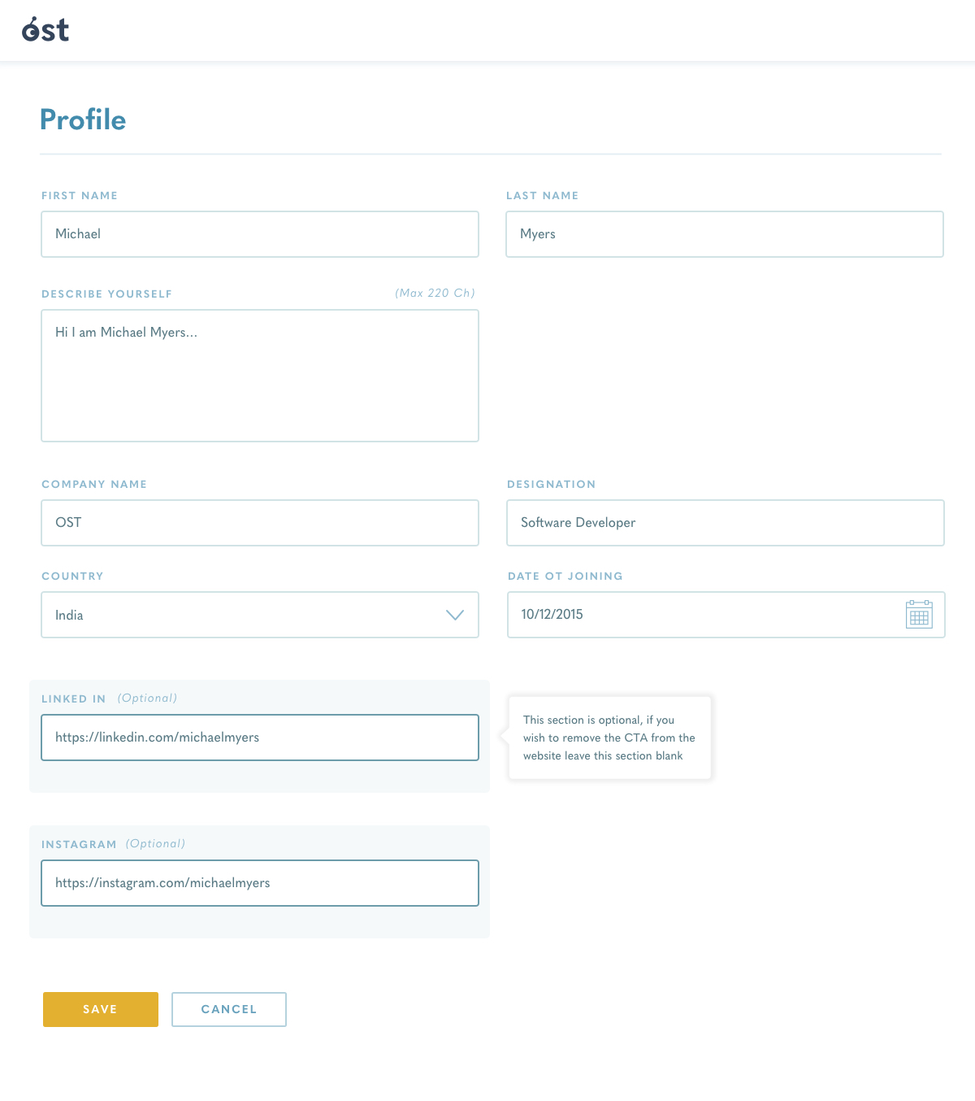

## Specs for breakpoint XL ( > 1200px)

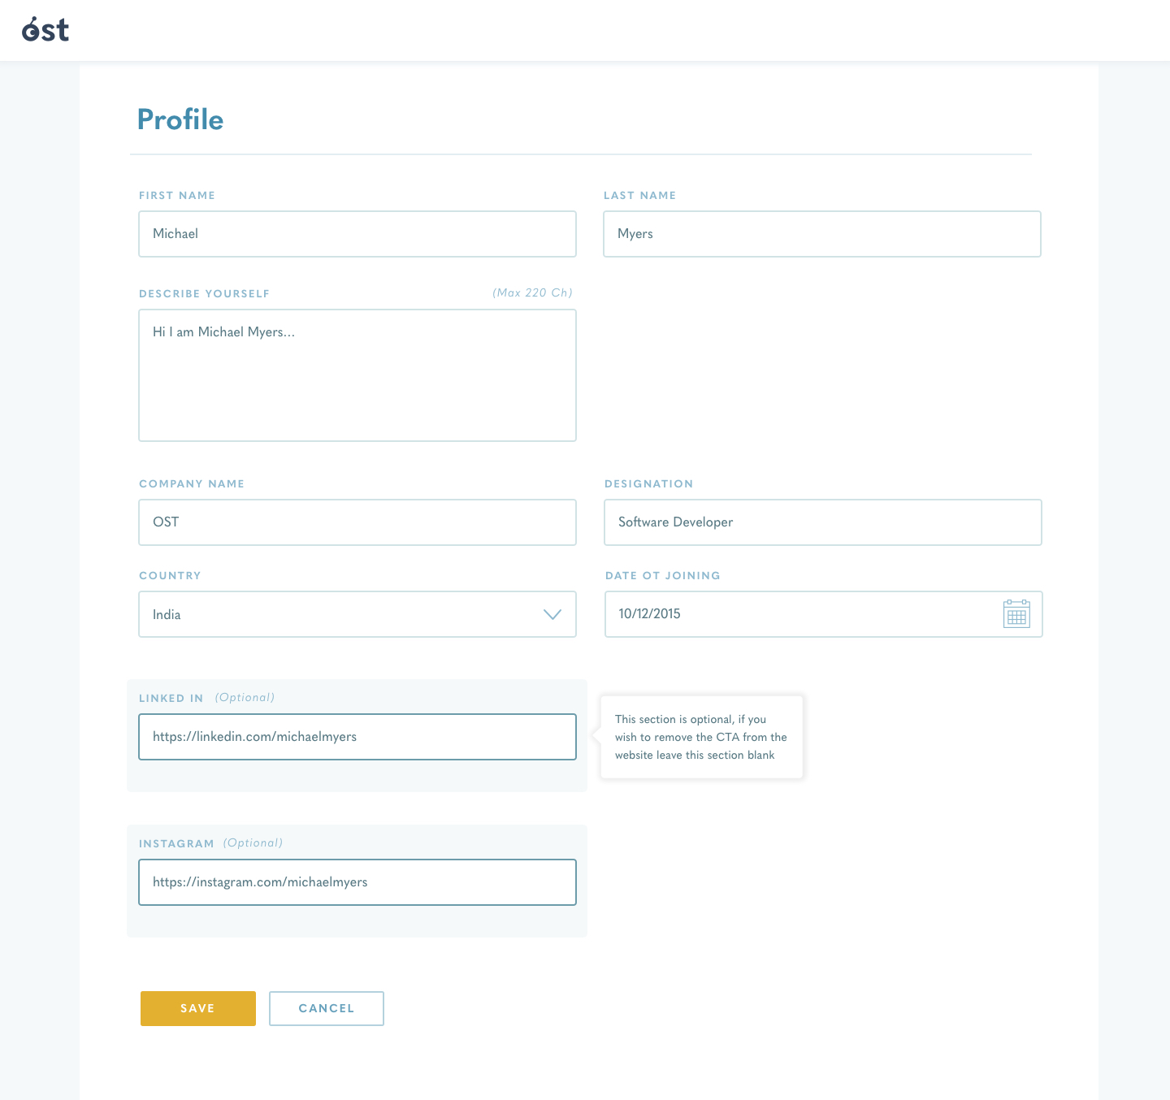

## Color & Font Specification

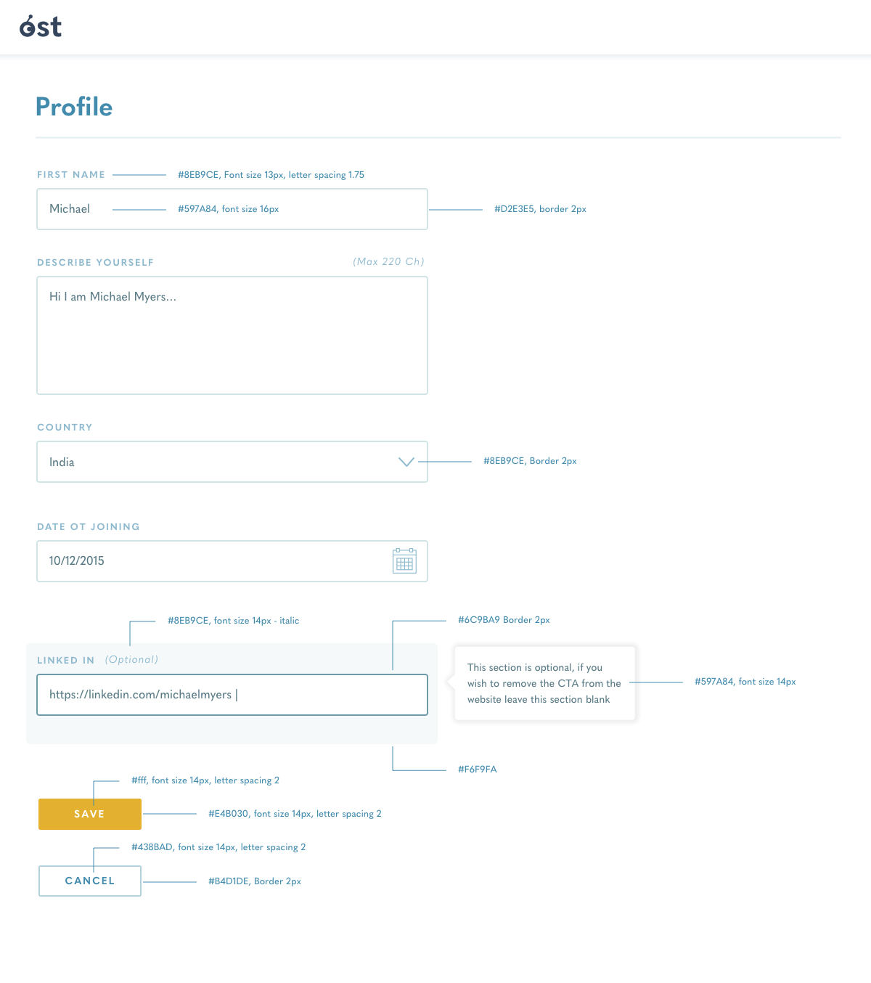

## 

## UX Requirements

### Validations.

All user input must be validated and feedback must be provided to user on the page.

Use jQuery Validation Plugin for this purpose. Here are the validation rules:

* 1. **First Name**

Only Alphabets and . (dot) are allowed. Max Length 50, Min Length 3. This is mandatory field.

* 1. **Last Name**

Only Alphabets and . (dot) are allowed. Max Length 50, Min Length 3. This is mandatory field.

* 1. **Describe Yourself**

All characters are allowed. Max Length 220, Min Length 5. This is mandatory field.

* 1. **Company Name**

Only Alphabets, Numbers, . (dot) and - (dash) are allowed. Max Length 50. This is mandatory field.

* 1. **Designation**

Only Alphabets, Numbers, . (dot) and - (dash) are allowed. Max Length 50, Min Length 2. This is mandatory field.

* 1. **Country**

HTML select with country codes in ISO-3166-1. This is mandatory field. See <https://www.freeformatter.com/iso-country-list-html-select.html>

* 1. **Date of Joining**

This is mandatory field.

* 1. **Linked-In**

This field is optional. max length 20, must be a valid URL if provided.

* 1. **Instagram**

This field is optional. Max Length 20. Must be a valid URL if provided.

### On Save Button Click

* 1. On click of save button, the form must be validated and all errors should be shown. Additionally, Bootstrap alert with danger styling should be shown.
     1. See <https://getbootstrap.com/docs/4.1/components/alerts/>
  2. If the form has no errors, Bootstrap alert with success styling should be shown.
     1. See <https://getbootstrap.com/docs/4.1/components/alerts/>

### Cancel Button Click

* 1. All form fields should be cleared.